Shaik Sharifa Jahan

AP22110011103

1. Write a program in assembly language to take a single-digit integer from the user

and print it on the screen.

**Code:**

org 100h

mov dx,offset msg_input

mov ah,09h

int 21h

mov ah,01h

int 21h

mov al,al

cmp al,'0'

jl notdigit

cmp al,'9'

jg notdigit

mov dx,offset msg_output

mov ah,09h

mov bl,al

int 21h

mov dl,bl

mov ah,02h

int 21h

jmp endprogram

notdigit:

mov dx,offset msg_error

mov ah,09h

int 21h

mov dl,bl

mov ah,02h

int 21h

endprogram:

mov ah,4Ch

int 21h

msg_input db 'Enter a digit: $'

msg_error db 0dh,0ah, 'It is not a digit$'

msg_output db 0dh,0ah, 'The digit entered is: $'

end

**Output 1:**

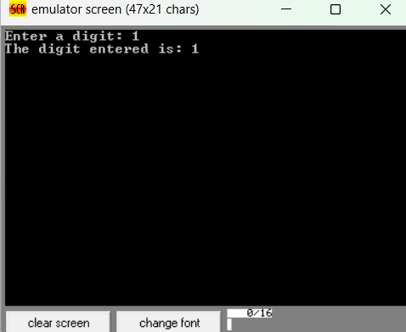

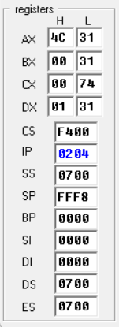

**Output 2:**

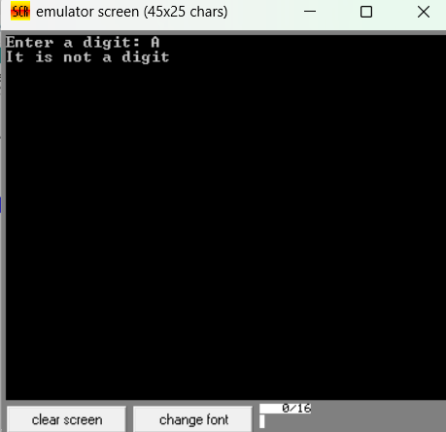

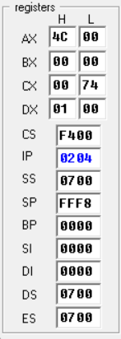

2. Write a program in assembly language to take two single-digit integers from the

user and print the result of subtraction on the screen.

**Code:**

org 100h

mov dx,offset msg_input1

mov ah,09h

int 21h

mov ah,01h

int 21h

mov bl,al

mov al,al

cmp al,'0'

jl notdigit

cmp al,'9'

jg notdigit

mov dx,offset msg_input2

mov ah,09h

int 21h

mov ah,01h

int 21h

mov cl,al

mov al,al

cmp al,'0'

jl notdigit

cmp al,'9'

jg notdigit

mov dx,offset msg_output1

mov ah,09h

int 21h

mov dl,bl

mov ah,02h

int 21h

mov dx,offset msg_output2

mov ah,09h

int 21h

mov dl,cl

mov ah,02h

int 21h

mov dx,offset msg_output3

mov ah,09h

int 21h

sub bl,cl

add bl,30h

mov dl,bl

mov ah,02h

int 21h

jmp endprogram

notdigit:

mov dx,offset msg_error

mov ah,09h

int 21h

endprogram:

mov ah,4Ch

int 21h

msg_input1 db 0ah,0dh, 'Enter integer 1: $'

msg_input2 db 0ah,0dh, 'Enter integer 2: $'

msg_error db 0ah,0dh, 'Not a digit $'

msg_output1 db 0ah,0dh, 'The difference of $'

msg_output2 db ' and $'

msg_output3 db ' is $'

end

**Output 1:**

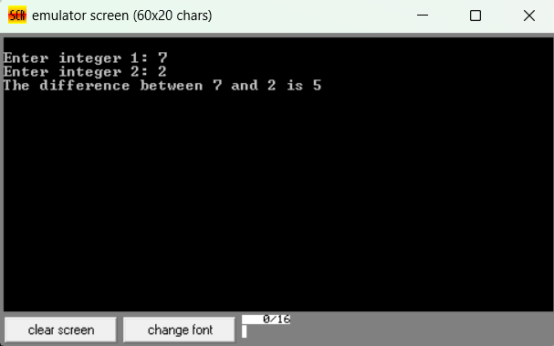

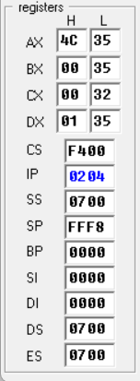

**Output 2:**

